
Faculty of Science and Technology

CST3340
Business Intelligence

Coursework 1

Module Leader: Ariadne Tsiakara

Term (AY) 2025 - 26
Duration of the module in weeks: 12 weeks
Document Version: 1

Coursework 1 – Business Intelligence

1. Overview

This section contains all the material for Coursework 1. It is worth 40% of the final grade for this module.
This coursework is based on a case study of your choice. The case study should represent a scenario where data can be used to improve the decision-making process of an organisation.
The submission should be in the form of a report of no more than MAX 2500 word, see below for more details. Your report will be based on the material covered in the lectures and labs, but you are also expected to carry out your own research.

2. Important Dates

You must ensure you meet the deadlines for each element.

Element | Type | Due Date
Coursework 1 | Formative Feedback | During lab sessions week 4.
Coursework 1 | Final Report | End of week 5.
Coursework 1 | Summative Feedback | Week 7.

3. Plagiarism

Plagiarism in database design is easy to spot. Please be aware that the penalties are severe and your final degree award classification is at risk.

4. Coursework Content

All Parts should be done Individually.

5. Where to submit

Each student should submit its report with the format of MS Word document.
Please include your Student ID and Full Name in the file name. All submissions should be via the submission link in your learning environment (MyLearning).

Do not hand, written assessed coursework directly to your tutor, and do not submit it by email to your tutor.

6. Coursework Requirements:

Case Study

This coursework should be carried out on a relevant case study of your choice. The case study should represent a scenario where data can be used to improve the decision-making process. The submission should be in the form of a report of no more than 2500 word, see below for more details. Your report will be based on the material covered in the lectures and labs, but you are also expected to carry out your own research.

Please agree your organisation with your lab tutor before week 2.

Your Tasks

- The Case Study (15 marks) (approx. 360 words)
A brief overview of your chosen case study, which clearly describes the scenario where data can be used to improve the decision-making process.

This section has been extensively discussed in the labs. The case study can be any organisation of your choice but you must highlight a least one situation/scenario where data can be used to improve the decision-making process. This situation is the example you will use throughout your report.

- The Data Requirements (15 marks) (approx. 360 words)
A detailed discussion of the data requirements of your scenario. This should include a discussion of both:
- Internal data, data collected locally.
- External data, data collected by external bodies.

This section has been extensively discussed in the labs: You are required to consider your example discussed in the case study section above. For this example, you need to discuss the data (both internal and external) that is relevant to the decision-making process highlighted. The data discussed should be collected while undertaking the normal day to day operations of your case study/example. You need to discuss the actual data collected in detail and where it will be stored i.e., the data source. You can give an overview at the beginning of the section and then a more detailed discussion.

- The Data Storage (55 marks) (approx. 1420 words)
A discussion of data identified in the data requirements section which would be suitable for storage.

This section should highlight the data discussed in the “Data Requirements” section above that is suitable for decision making for your scenario. You will use examples from this data to discuss the following sections.
  - A discussion of the advantages and disadvantages of a data warehouse.

This could include:
An example and brief discussion of one suitable data schema. E.g. A star, snowflake or galaxy schema.
In this section you could draw and discuss 1 schema. The diagram should contain the fact table (including the surrogate keys and the facts) and 4/5-dimension tables (remember a dimension table must have a hierarchical structure). You then need to clearly explain the different parts of the schema. This diagram is mandatory for this section. Example of a proper schema is below.
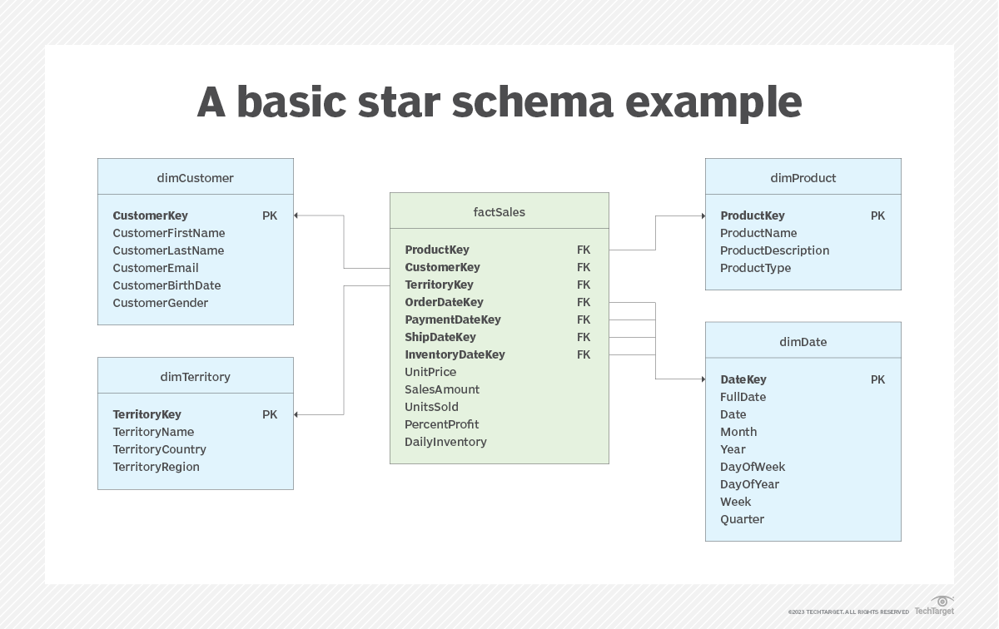

  - Using examples from your scenario, a discussion of
- The ETL process.
This section should discuss the 3 processes, The E, the T and the L. Use examples from your case study to discuss the 3 stages of the process and different techniques that could be used at each stage. The discussion should include which techniques are best for your case study example.

- Online Analytical Processing (OLAP).
This section should discuss the different OLAP operations, slicing/dicing/pivoting/roll-up/roll-down. The discussion should use examples from your case study example. The OLAP techniques could be address by drawing sample cubes and then discussion them. Your discussion could include 1 query that is relevant to the schema provided and explain which OLAP operations would be used to provide an answer.
You are NOT expected to discuss ROLAP, MOLAP, HOLAP.

- A discussion the advantages and disadvantages of a big data system.

This could include:
- Big Data
This section should define big data using the Vs. at least the 3Vs. It should then highlight which of the data discussed in the “Data Requirements” section above is unstructured/big data and therefore could not be stored in a data warehouse. You will use examples from this data to discuss the following sections.

- A discussion of reasons the data is not suitable for storage in a data warehouse.
This section should discuss why a Data Warehouse cannot handle big data, e.g.,
1. Volume and Velocity of Big Data passing through the ETL process.
2. Speed of analysis required i.e., real time.
3. Variety of data, unstructured, semi-structured etc.
Make sure you relate the discussion to your case study by using examples from it.

- Using examples from your scenario, discuss a framework that could be used to collect, store and analyse this data.
This section should discuss one Big Data framework. If you use Hadoop, then you need to discuss how Hadoop works including the different components such as MapReduce and HDFS. Make sure you relate the discussion to your organisation by using examples from it.

- A discussion of the advantages and disadvantages of using cloud storage.

This could include:
- A discussion of cloud computing in general.
- A discussion of the use of cloud for storage of data for a Data Warehouse
- A discussion of the use of cloud storage of data for big data systems.

- Conclusion (15 marks) (approx. 360 words)

This should include a summary of the report and suggest the most appropriate data strategy for your scenario.

The conclusion should:
1. Summaries the data that your case study collects during its normal activities.
2. Briefly discuss if it is structured data (Data Warehouse data) or unstructured (Big Data)
3. Recommend an appropriate data strategy for your case study which could be one of the following:
a. If the data is mostly structured data, then just have a DW without a Big Data Framework
b. If the data is mostly big data with limited structured data, then just have a big data framework without a DW.
c. If the data is a mix of structure data and big data, then have a hybrid system which includes both a DW and a big data framework. Data should be allowed to flow between the two system.
d. If cloud data storage would be an advantageous for any of the above data strategies.
e. You need to justify your recommendation.

Coursework 1 Individual Report marking criteria rubric.
Criteria | 1-4 First | 5-8 Upper Second | 9-12 Lower Second | 13-16 Third | 17-20 Refer
 | 70%+ | 60%-69% | 50%-59% | 40%-49% | Less than 40%
Introduction (15%):  A clear rationale for the chosen case study and decision-making scenario. | Outstanding discussion and justification of chosen case study and decision-making scenario | Thorough discussion and justification of chosen case study and decision-making scenario. | Evidence of some discussion and justification of chosen case study and decision-making scenario. | Adequate discussion and justification of chosen case study and decision-making scenario. | Discussion and justification of chosen case study and decision-making scenario is inadequate.
Discussion: The Data Requirements (15%)  Relevant and informative, applying depth of knowledge and understanding. | Excellent and well-informed understanding of theories and concepts involved. | Good understanding of theories and concepts involved. | Demonstrates satisfactory knowledge and  understanding theories and concepts. | Adequate content; limited depth of knowledge and understanding shown. | Inadequate content; limited depth of knowledge and understanding shown.
Discussion: The Data Storge (55%)  Relevant and informative, applying depth of knowledge and understanding. | Excellent and well-informed understanding of theories and concepts involved. | Good understanding of theories and concepts involved. | Demonstrates satisfactory knowledge and  understanding theories and concepts. | Adequate content; limited depth of knowledge and understanding shown. | Inadequate content; limited depth of knowledge and understanding shown.
Conclusion (15%):  Clear conclusions from the literature and topics discussed in the work and justification of data strategy proposed. | Tightly structured, logical and draws coherent conclusions to the topics covered. | Undertakes a systematic analysis of the issues and draws coherent conclusions to the topics covered. | Clear conclusions to the topics covered. | Adequate conclusions to the topics covered. | Inadequate conclusions to the topics covered.
References: for all above sections.  Reference to sources including directions for further study. | Broad and relevant readings examined and used selectively in the work. | Good range of appropriate references used during the review. | Conventional references and readings used within the review. | Adequate but limited use of references during review. | Review relies on no or one reference; evidence of unexamined personal opinion.
Presentation: for all above sections.  Clearly presented with limited spelling and grammatical errors. | Very well expressed and understanding of content with limited spelling or grammatical errors. | Very well expressed; good understanding of content with some spelling and/ or grammatical errors. | Well expressed; understanding of content with many spellings and/ or grammatical errors. | Simple expression of information; little understanding of content; several spelling and grammatical errors. | Inaccurate expression of information: lacks understanding of content; many spelling and grammatical errors.

